Day 6- 113145793 -Dipesh varma

Day 6

*List all the regular expressions and their meaning
. (dot): Matches any single character except newline.
\d: Matches any digit (0-9). (equivalent to [0-9])
* (asterisk): Matches zero or more occurrences of the preceding character/group.
[] (Character Set) Matches any one character listed inside the brackets
[^] (Negated Character Set) Matches any one character not listed inside the brackets. The ^ immediately after [ negates the set.
() (Parentheses): Groups multiple characters or patterns together so that a quantifier can apply to the whole group (e.g., (ab)+)
| (Pipe or Vertical Bar): Acts as an "OR" operator. Matches either the expression before the pipe or the expression after it.
\ (Backslash): Escapes a special character to treat it as a literal character.
{n}: Matches exactly n occurrences of the preceding character or group.
[^] (Negated Character Set) Matches any one character not listed inside the brackets. The ^ immediately after [ negates the set.
+ (Plus Sign) Matches one or more occurrences of the preceding element. (Greedy by default)
$ (Dollar Sign) : Matches the end of the string. In multiline mode, it matches the end of a line.
^ (Caret) Matches the beginning of the string. In multiline mode, it matches the beginning of a line.

If you are aware of Linux OS.. can you tell me the feature of Linux.
Open source and free:- Linux is inspired from Unix but unlike Unix Linux is open-source programme.

Multitasking Capabilities:- Linux is optimized to run different programme simultaneously. It can efficiently manage CPU and Ram resources to carry out tasks efficiently.

Multi-User Support: Multiple users can access the resources at same time. As the different users has their own permissions and environment which ensures data isolation and security.

Stability:- Linux programs has been known for running for months or in some cases years without requiring reboot. That is why its an ideal choice for servers

Portability and Flexibility: Linux is portable. It does not require any high-end configuration machine to run, it can run on various hardware’s like routers, TVs, smartphone, computers. As it modular design allows to only install the necessary features unlike other OS which requires full package installation.

Strong Community Support: - As its an open-source programme, the community support if vast for Linux. Lots of documents and forums are readily for learning and development.

Customization :- Linux offers lot of customization options. Users have control over the different aspects of the programme to customize it. This allows to build the programme as per the requirement.

What is Kernal ? can you explain about it in your words.
Kernal is like an engine of a vehicle or manager which manages all the other workers. It acts like a bridge between the hardware to carry out tasks smoothly and keep everything organized.

BASH in Linux full form and Explanation.
Bash stands for Bourne Again Shell. Bash is a tool or a medium by which we can give instructions to linux . As one cannot talk in plain English to Linux bash is a language which we use to carry out tasks or give instructions. The goal to create BASH was to make commands more user friendly.

What do you think is the difference between Linux and Windows.
Linux is open-sourced, and Windows requires licensing. As the Linux is customizable one has the immense control over almost every aspect of the operating system. Windows has limited customization options for its core functionality. Due to its open-source nature Linux has a strong community support. In Linux user has more control over the updates, users can select the updates to install as per their choice or requirements. Updates in windows are mandatory, and users does not have much control over the updates to select. And it also requires forced reboot which might cause inconvenience.

What are the basic components of Linux? Describe each in detail with diagrams.
Hardware Layer: it consist all the physical components of your computer the CPU (the brain), RAM (short-term memory), hard drive/SSD (long-term storage), keyboard, mouse, monitor, network card, graphics card, etc. These are the raw physical resources that the operating system needs to manage and control to make your computer functional. If the kernel is the brain then hardware can be considered as the body parts.
System Libraries:- These are collections of pre-written, reusable code snippets and functions. Its line an pre built tool to complete the tasks. It is used for simply the development as the users does not has to write the all the codes by themselves. The most famous is the GNU C Library (glibc). Its is like a prebuilt tool which user does not have to build again and again.
Kernel:- kernel is like an engine of a car. The Kernel is the master manager or central brain of the entire system. It is responsible to manage resources, it decides how processing power a proramme gets to run. Kernel decides that how much hardware resources should be allocated to a programme.
GNU Core Utilities (Shell Utilities): These are the essential, basic command-line programs that perform fundamental operations in a Linux system. They are often referred to collectively as the "core utilities" because they are the building blocks of most command-line interactions.
ls: List files and directories.
cp: Copy files and directories.
mv: Move or rename files and directories
rm: Remove (delete) files and directories
mkdir: Make new directories.
grep: Search for text patterns within files
cat: Display the content of files.

Desktop Environment (DE) :- This is the complete Graphical User Interface (GUI) that most average users interact with on a daily basis. It's a comprehensive suite of software that provides the visual "look and feel" of your Linux system. It provides a user-friendly, intuitive graphical experience, similar to what you find in Windows or macOS. It includes:
Applications :- These are the software programs you use to perform specific tasks and get work done. They are the highest layer from a user's perspective.
Web Browsers: Firefox, Google Chrome
Office Suites: LibreOffice (Writer, Calc, Impress)
Media Players: VLC, Rhythmbox.
Development Tools: IDEs, code editors, compilers.

Graphical Server (X11 / X.Org Server, Wayland) :- If you're using Linux with a graphical interface (like you would with Windows or macOS), this software layer is essential. It's responsible for managing how graphical elements are drawn on your screen and how input from your mouse and keyboard is handled.This is the factory's display engineer. It's responsible for knowing exactly where and how to project visuals onto the main control room monitors and ensuring that signals from the control panel (mouse/keyboard) are correctly registered.
Shell (Command Line Interface - CLI) :- This is a program that provides a text-based interface between you and the Linux Kernel and other utilities. When you open a "Terminal" window, you're interacting with a shell (most commonly Bash
Command Interpreter: It takes the commands you type (e.g., ls -l /home), interprets them, and then passes them to the Kernel or other utilities for execution

Is it legal to edit Kernal ? when do you think we have to in case?
Yes, it’s legal to edit the Linux kernel as it is an open-source programme. Editing a closed sourced programme or a kernel that requires licensing can be illegal.

What is LILO? Explain
Lilo is a bootloader for Linux. Its job is to load the kernel which is the core of the operating system.
Its installed in Master Boot Record (MBR), mbr is a small tiny part of a harddrive or a space specially allocated to start at the beginning off the boot to start the bios/uefi
LILO has been largely replaced by GRUB (GRand Unified Bootloader), and its successor GRUB2 in almost all modern Linux distributions.

What is shell? How many shells are there and what are they ? can you explain.
shell is a program that acts as a command-line interpreter, it interpretes our command to the kernel. Its basically a translater between human and machine language.
There are many shells available but the most common are,
Bash You can easily recall and edit previous commands using arrow keys. Tab Completion: Pressing Tab auto-completes commands, file names, and directories, saving a lot of typing and reducing errors.
c. Z Shell (zsh)
d. KornShell (ksh)
Friendly Interactive Shell (fish)

What is swap space?
A space from hdd or sdd which is designated for an operating system to use as an extension of its physical memory(RAM).

What is Mount ? how do you mount and unmount file system in Linux?
"Mounting" is the process of making a file system (located on a storage device like a hard drive partition, USB stick, CD/DVD, or even a network share) accessible at a specific point within this unified directory tree. To mount one must have root access.
sudo mount [device_path] [mount_point_directory]
sudo umount [mount_point_directory]

What is chmod command ? how to use it?
chmod stands for change mode. Its primary purpose is to change the file system permissions of files and directories. In Linux, every file and directory have a set of permissions that dictate who can do what with it. These permissions are crucial for security and multi-user environments.
Can you add a new user account? Crate a new user in different ways and paste ss
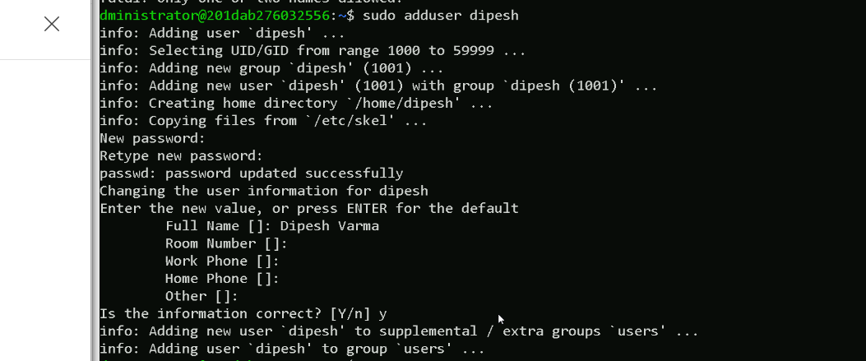

Can you change the password of a user? How do you do that? Plz share ss
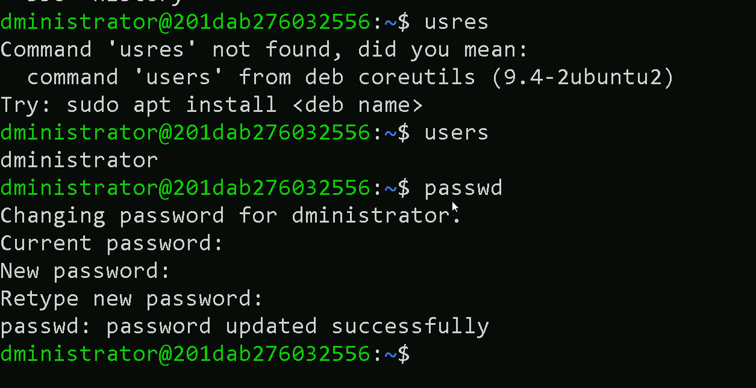

What is diff between Process and Thread?
Process is a completely self-contained, independent program that is running in realtime. For eg a web browser a game, for this OS creates a new process for it to run. It can be viewed in task manager. Process is like an complete separate factory(programme) inside its own building(Operating system)
Programs use threads to achieve concurrency (making progress on multiple tasks seemingly at the same time). A web browser: One thread renders the webpage, another downloads images, and another plays embedded videos.

What are the default permissions for a new file ? Plz find out for Owner → ? Group → ? All and others → ?
When a new file is created in Linux, the default permissions before applying umask are: Owner → rw- (read and write) → 6 Group → rw- (read and write) → 6 Others → rw- (read and write) → 6 So, default permission is: 666 (in octal). However, after applying the default umask value (usually 022), the effective permissions become: Owner → rw- → 6 Group → r-- → 4 Others → r-- → 4.

*Post this task the VM got disconnected so posting the history of the written codes*

